Assessment 2

# Name: Loukik Bhangale

# Reg No: 17BCE0961

# Solt: L9+L10

# Code:

from nltk.corpus import stopwords

from nltk.tokenize import word_tokenize

def cleaner(filename):

filevariablename=open(filename).read()

stop_words = set(stopwords.words('english'))

word_tokens = word_tokenize(filevariablename)

filtered_sent = [w for w in word_tokens if not w in stop_words]

filtered_sentence = []

for w in word_tokens:

if w not in stop_words:

filtered_sentence.append(w)

#print(word_tokens)

#

#print("stop words removed!")

punctuations = list('''!()-[]{};:'"\,<>./?@#$%^&*_~''')

temp=[]

for char in filtered_sentence:

if char not in punctuations:

temp.append(char)

filtered_sentence=temp

#print(filtered_sentence)

return filtered_sentence

def distinct(doc,li):

for items in doc:

if items not in li:

li.append(items)

doc1=cleaner("Doc 1.txt")

doc2=cleaner("Doc 2.txt")

doc3=cleaner("Doc 3.txt")

doc4=cleaner("Doc 4.txt")

doc5=cleaner("Doc 5.txt")

doc6=cleaner("Doc 6.txt")

doc7=cleaner("Doc 7.txt")

doc8=cleaner("Doc 8.txt")

doc9=cleaner("Doc 9.txt")

doc10=cleaner("Doc 10.txt")

dislist=[]

finaldic={}

posdic={}

def discounter(docnamev,dicvarname):

temp={}

temp2={}

distinct(docnamev,dislist)

for item in dislist:

c=docnamev.count(item)

temp[item]=c

temp3=[]

for stuff in range(len(docnamev)):

if item==docnamev[stuff]:

temp3.append(stuff)

temp2[item]=temp3

finaldic[dicvarname]=temp

posdic[dicvarname]=temp2

discounter(doc1,"Document 1")

discounter(doc2,"Document 2")

discounter(doc3,"Document 3")

discounter(doc4,"Document 4")

discounter(doc5,"Document 5")

discounter(doc6,"Document 6")

discounter(doc7,"Document 7")

discounter(doc8,"Document 8")

discounter(doc9,"Document 9")

discounter(doc10,"Document 10")

#run it twice because updation distinct list

discounter(doc1,"Document 1")

discounter(doc2,"Document 2")

discounter(doc3,"Document 3")

discounter(doc4,"Document 4")

discounter(doc5,"Document 5")

discounter(doc6,"Document 6")

discounter(doc7,"Document 7")

discounter(doc8,"Document 8")

discounter(doc9,"Document 9")

discounter(doc10,"Document 10")

def printable():

print("Documents",end='')

for item in dislist:

print("\t"+item,end='')

for item in finaldic:

print(item,end='\t')

for stuff in finaldic[item]:

print(finaldic[item][stuff],end="\t")

print("\n")

#suming up the number of occurance of each words

diclist={}#dictionary of sum of each word occurance in all the documents

for item in dislist:

t=0

for stuff in finaldic:

t+=finaldic[stuff][item]

diclist[item]=t

#here if you print diclist you get the total occurance of all the words that have appeared in every document used.

def maxword(a):#this finds out if the word exists and if it does then it finds where it occurs maximum and also prints out it's positions

maxc=0

maxdoc=0

if a in dislist:

for item in finaldic:

if ((finaldic[item][a])> maxc):

maxc=finaldic[item][a]

maxdoc=item

print ("The word {0} has occured the most in {1}, {2} number of times, in positions:".format(a,maxdoc,maxc))

print(posdic[maxdoc][a])

else:

print ("This word does not appear in the documents")

print ("Enter the number of the function you want to see.\n")

print ("1.See the table of all words and counts respective to their documents.\n")

print ("2.Type in a word and check where it occurs the most and at what positions.\n")

print ("3.See the total occurance of all the words that have appeared in every document used.\n")

n=int(input())

if n ==1:

printable()

elif n==2:

t=input()

maxword(t)

elif n==3:

print(diclist)

else:

print("Invalid input!.")

# Output:

## Table:

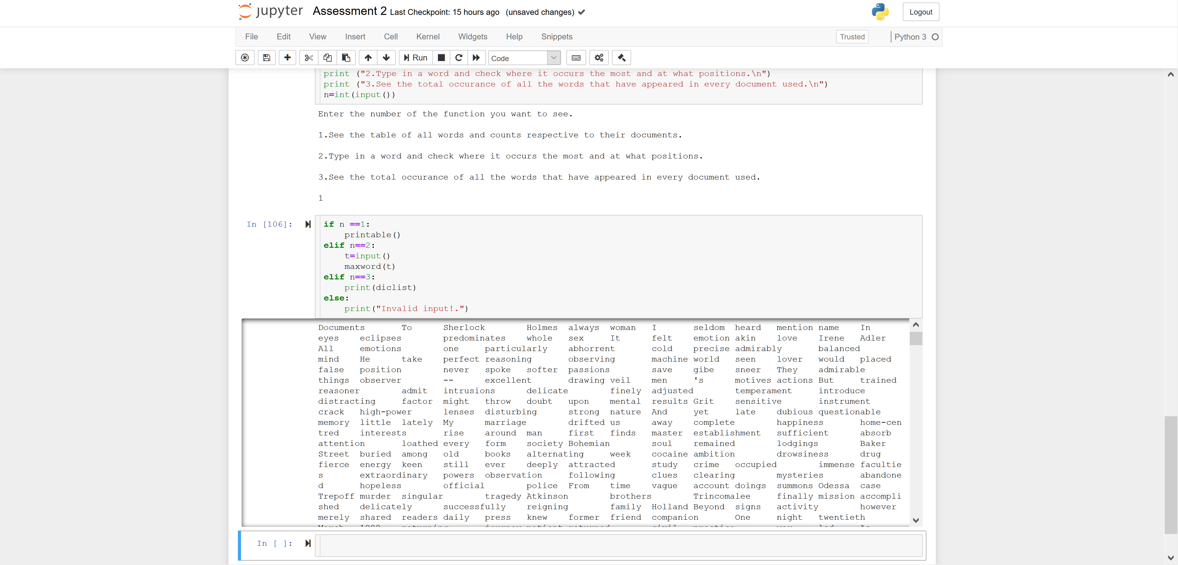

## Word query:

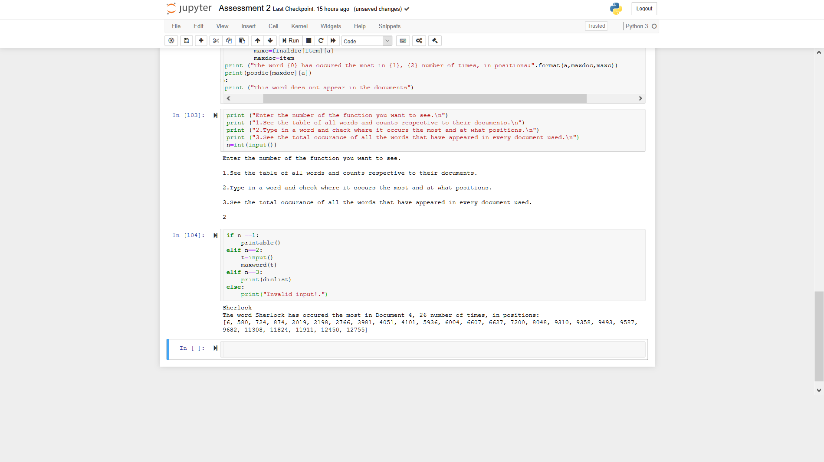

## Sum of occurance:

